Planning Permission
Q1.What is a development plan and why is it necessary to have a development plan for a county?
Answer.
A development plan is a document which details the overall strategy of the council for the proper planning and sustainable development of an area and generally consists of a written statement and accompanying maps. The plan usually includes the broad aims of the council for specific topics, e.g. housing, infrastructure, community facilities which are reinforced by more detailed policies and objectives.

Q2.What role do the following people have in the formation of a counties development plan.
Answer.
- Land Owners
Land owners may make written submissions to the county council to have their land included in the development plan.
- County Councillors
County Councillors vote on the proposed development plan.
- County Planners
County planners formulate the overall plan and present it to the councillors to consider.
- Minister for Enviroment
The Minister for enviroment may if he/she so wishes amend or alter the development plan.

Q3.Towns and villages can de divided into different zones, name 4 of these zones and state what each zone means.

Answer.
High Density Housing
Apartment blocks and houses close together would be built in these areas.
Educational Areas
Schools colleges and other educational institutions can be built in these areas.
Town Centers
Town centres are generally reserved for restaurants shops and social outlets.
Business and Industry
Factories and Industrial estates would be located in these areas

Q4. There are 3 different categories of planning permission name the 3 and write a short note on 3 of the types.

Answer.
- Application for Outline Permission
Outline permission relates to the general nature of the development or to a particular use for land. Not concerned with specific details like design, materials, etc. Outline permission should be sought if there is any possibility that the development may not be allowed.
Once a land owner has been granted outline planning permission the owner still has to apply for permission in order to build.
- Application for Permission
When granted it entitles the applicant to proceed with the proposed development. Applications must be accompanied with detailed drawings of the development, a copy of the site notice and newspaper ad, site map and site location map.
- Application for Retention
Houses or buildings that have been built without any planning permission may apply for retention.

Q5 What is the function of a pre planning meeting with a county planner.
Answer.
County Councils hold on-going pre-planning meetings both commercial (business) and one-off houses to provide advice to persons intending to apply for planning permission.

Q6. Applying for planning permission has 5 stages, state what happens at each stage.
Include the documents that should be included with your application.

Answer.

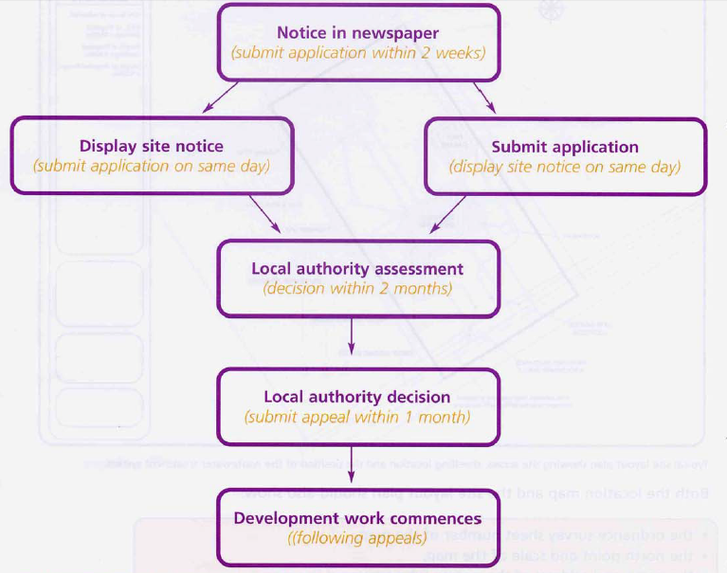

In general, you will need to submit the following documents with your application:

- *A location map (6 copies).
- *Site or layout plan (6 copies).
- Other plans, elevations and sections (6 copies).
- *Copies of public notices (newspaper and site).
- *A plan showing the position of a site notice or notices.
- The appropriate fee.

Q7 What is the fumction of An Bord Pleanala.
Answer.
An Bord Pleanála is an independent body that decides on appeals from planning decisions made by local authorities in Ireland.

Q8 What is an Enviromental Impact Statement.
Answer.
An Environmental Impact Statement (EIS) is a document prepared to describe the effects for proposed development and its activities have on the local environment.

Q9 When did Planning Permission become a requirment in Ireland?
Answer.
Planning Permission became a requirment in Ireland in 1963

Q10 Outline when planning permission is not needed for a development?
Answer.
Generally minor changes such as those listed below do not need planning permission.

- Building an extension to the rear of the house which does not increase the original floor area of the house by more than 40 square meters and is not higher than the house.
- Converting a garage attached to the rear or side of the house to domestic use

- Building a front porch so long as it does not exceed two square meters in area

Q11 Why is planning permission necessary?
Answer.
- It gives people the right to object to new buildings.
- It prevents development without the thoughts and considerations for residents of an area.
- So that buildings must conform to the terms of the development plan as set out by the particular Planning Authority for the particular area.
- So that the Planning Authority can decide if a building blends in with the surroundings. i.e. the landscape.

