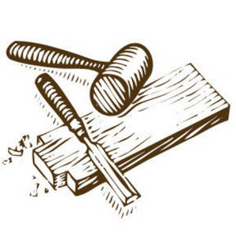**Construction Studies Project**

**Exam No _______________**

**Contents**

* Design Brief
* Brief Analysis
* Investigation & Research
* Possible Solutions
* Final Solution
* Working Drawings & Cutting List
* Making of My Project
* Experiments
* Evaluation & Conclusion

Design

Brief

Brief

Analysis

Investigation & Research

Possible Solutions

Final Solution

Working Drawings & Cutting List

Making of My Project

Experiments

Evaluation

&

Conclusion