Windows
Q1. What is the main function of a window?
ANSWER
Admit light and air into the building.
Provide occupants with an outside view.
Provide both thermal and sound insulation.
Provide both safety and security for the home.

Q2. Name 3 materials used to make windows and give one advantage and one disadvantage for each material.
ANSWER
Wood
Advantage – Cheap and easiily available
Disadvantage – Needs to be traeted and regularly maintained.
Aluminium
Advantage – Durable and lightweight.
Disadvantage – Cold material and tends to condensate.

uPVC
Advantage – Versatile material with good thermal properties.
Disadvantage – Can be expensive.

Q3.Draw a diagram and name the 3 window types shown below.
A B C

A = Casement Window
B = Up and Down Window
C= Pivot Window

Q4. Draw a 3d diagram of a wooden window frame with a double glazed panel.

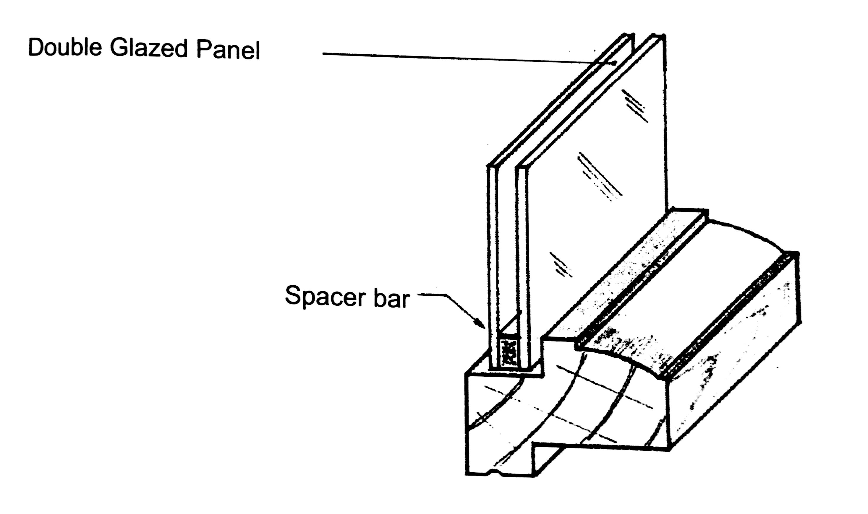

Q5. Draw the window and name all the components labeled below.

A – Side Hung Slash
B – Mullion
C – Sill
D – Stile
E – Transome
F – Head
G – Top Hung Sash.

Q7. Show using notes and free hand sketches how dampness is prevented from entering around a window.

One method of preventing dampness form entering a building is by wrapping DPC around the concrete cill.

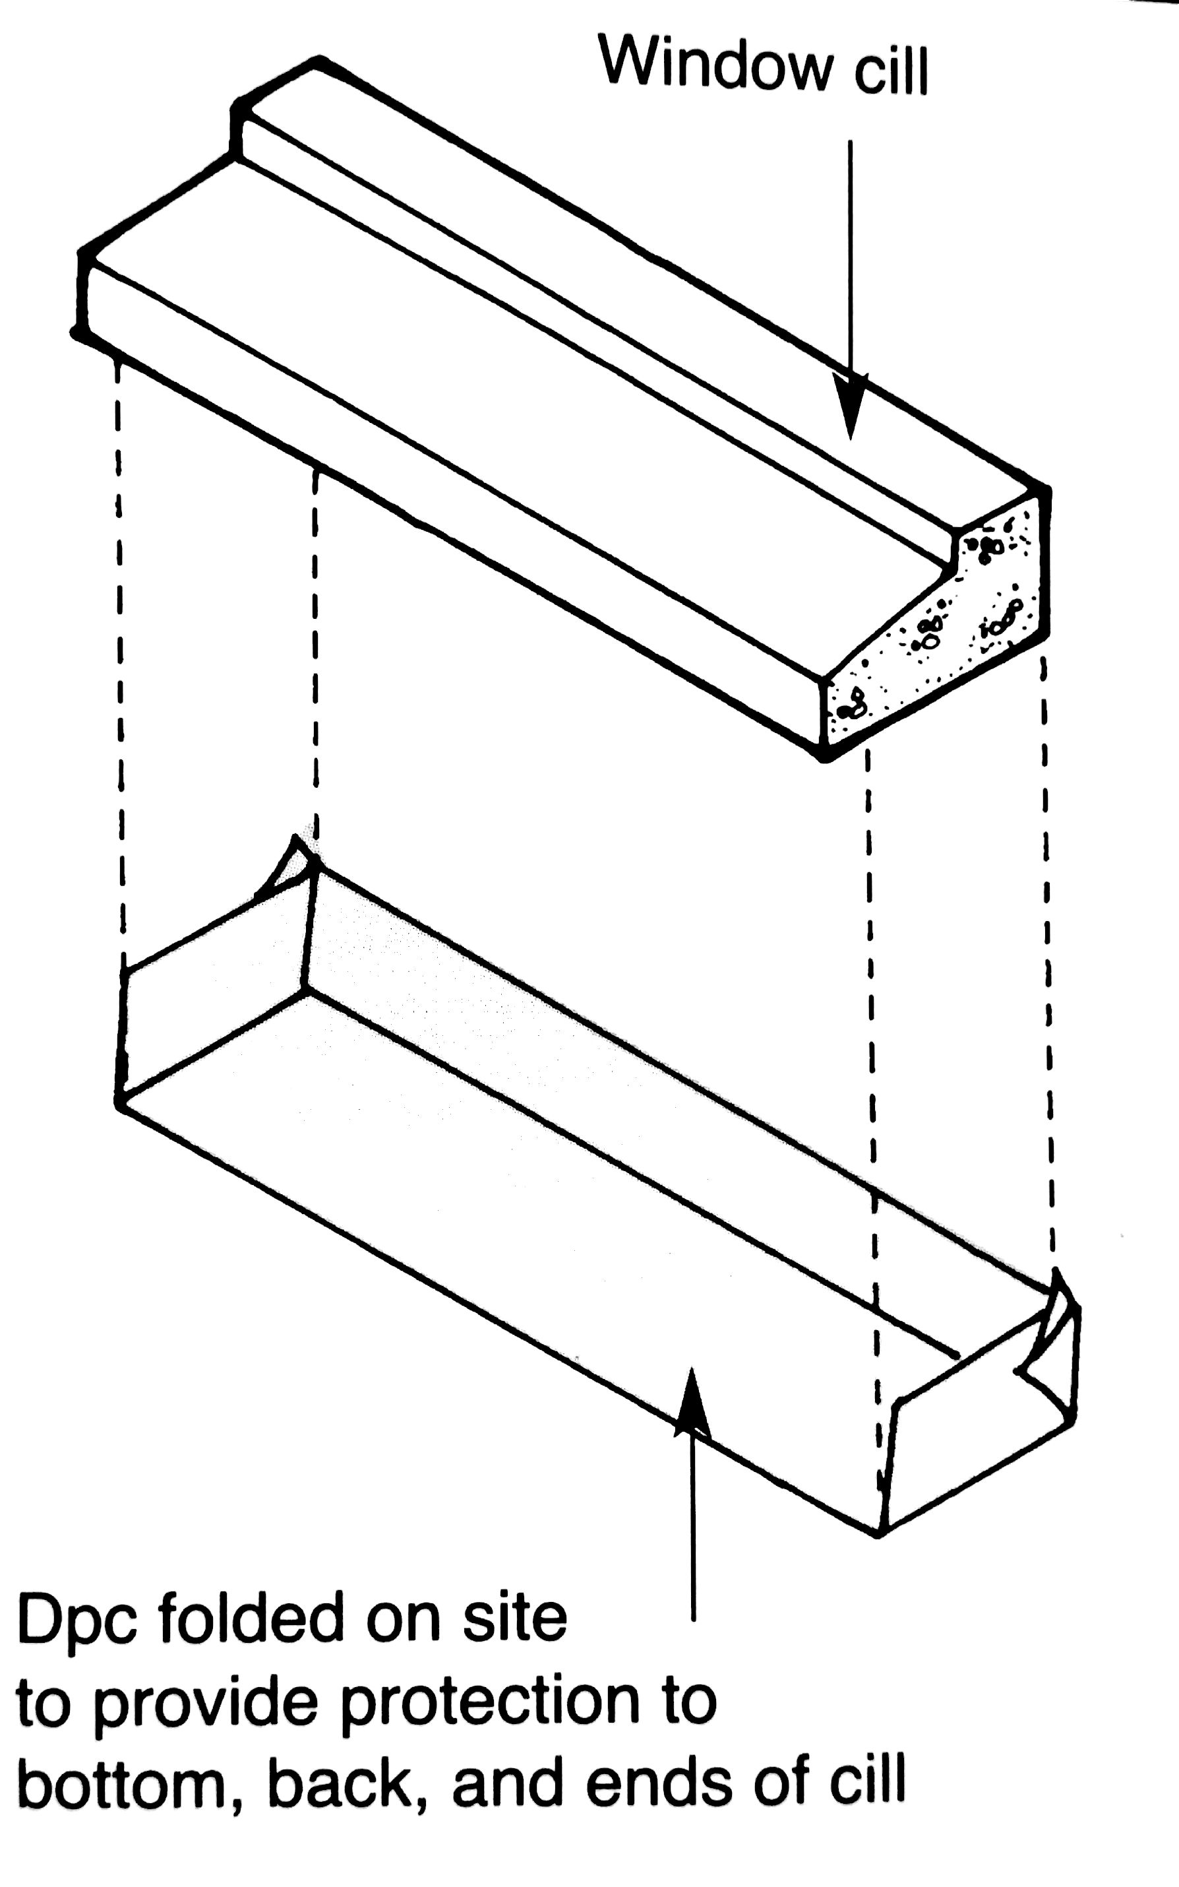

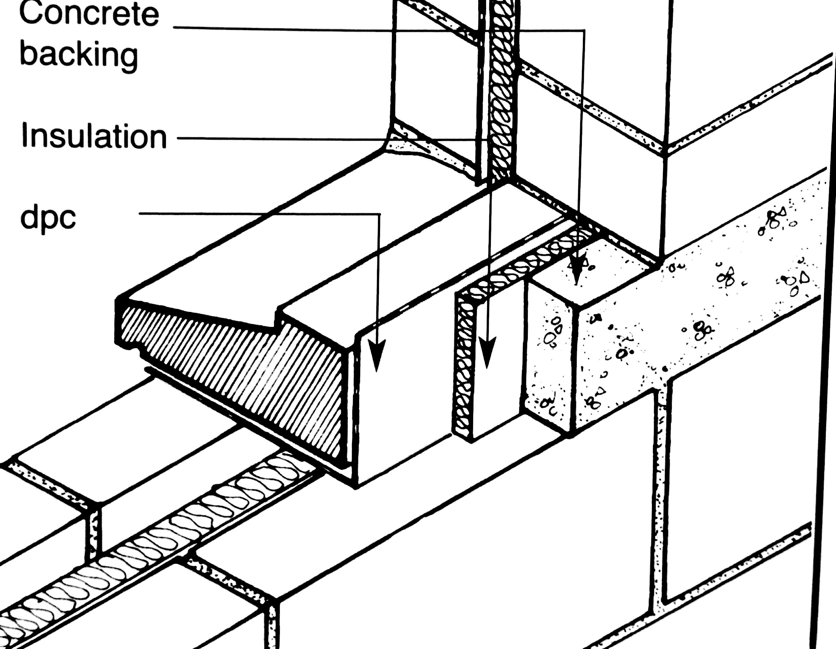

Second method
Ensure that sealant is used around the window head, cill & stiles after they have been fixed to the openings. The diagram below shows a horizontal section of cutting through a window stile.

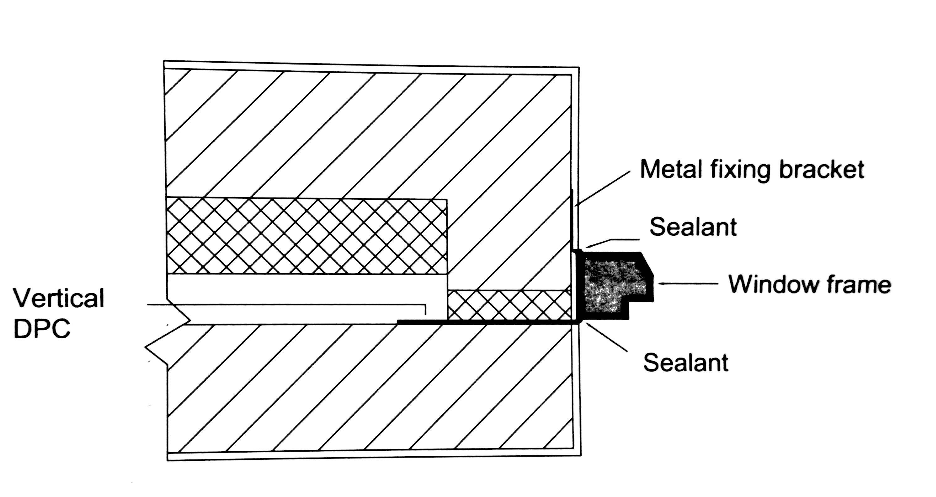

Q6. Draw a coloured labelled sketch of a window cill and head.

